# SEP 6, 2021 News

Marina Fleets Debuts ‘Search Alerts’ as Buyers Scour Fast-Moving Luxury Boat Market

**MIAMI, sep. 6, 2021 —**[Marina](https://www.yachtworld.com/) fleet, the largest global marketplace for boats and yachts, announced today a new automated service called Search Alerts, to keep boat buyers on top of the fast-moving luxury market. When demand is high and competition is fierce, not being among the first to know of a new listing could easily mean “missing the boat”. Search Alerts have replaced the portal’s retired Personal Boat Shopper tool and offer a better user experience that makes subscribing to any number of custom notifications faster and monitoring desired inventory easier.

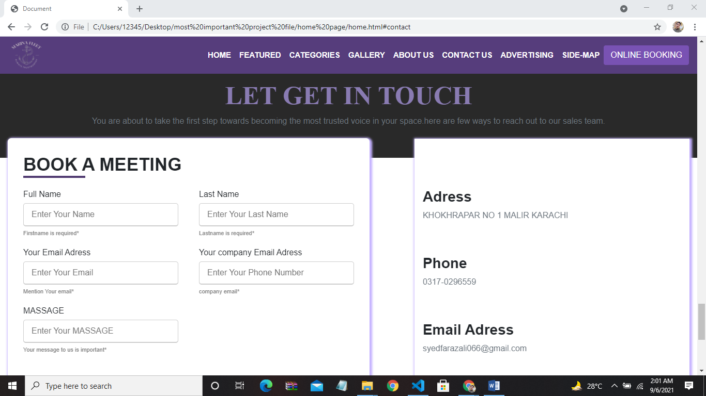

“MarinaFleet has long been relied upon for connecting buyers and brokers, so simplifying and revamping how our users save their custom criteria and sign up for convenient alerts was an obvious next step in our commitment to delivering a world-class shopping experience,” said

Courtney Chalmers, Boats Group’s VP of marketing. “As we have been [reporting](https://www.boatsgroup.com/news/) since May, boats are moving even more quickly in the wake of the pandemic and we’re excited to provide boat buyers with timely, easy-to-get updates about what is on the market and where to buy it.”

No two boat buyers are alike, nor are their preferences, and the new, oneclick feature is programmed to save curated searches and send weekly alerts of the most recent matching boats for sale. Having more than 10 filters set to sift the world’s largest selection of listings saves time at the start of the hunt for the ideal boat and puts buyers ahead of the pack as fresh inventory is introduced daily.

Furthermore, as boaters’ requirements are expanding during the era of social distancing, people are putting Search Alerts to work in smart ways. For example, “working-from-anywhere” is quickly becoming the longerterm plan for many professionals and buyers are exploring boats with spaces suitable for their unique work day. Besides getting their dreamboat fantasy fix, users are setting additional Search Alerts to explore unfamiliar makes to compare general arrangements and yacht specifications based on new needs.

“As inventory continues to turn over at an accelerated rate and more engaged shoppers are ready to buy, consumers – now more than ever before – need a service like MarinaFleet’s Search Alerts to keep them informed about available inventory,” said Chalmers. “Since launching, thousands of our shoppers have activated Search Alerts to ease their anxiety of ‘missing the boat’ and allow MarinaFleet to set sail and scour the market on their behalf.”

For more information about MarinaFleet and to create a custom Search Alert, visit [www.MarinaFleet.com.](http://www.marinafleet.com/) For additional ways to shop for boats, download the MarinaFleet app, follow @MarinaFleet on Instagram, and catch new boat reviews by subscribing to

YachtWorld’s[YouTube](https://www.youtube.com/channel/UCezuAUrhAcG_5h5USBkI90A)channel.

## About Boats Group

Boats Group’s brands – [MarinaFleets](https://www.yachtworld.com/)[, Boat Trader,](https://www.boattrader.com/) [Boats.com,](https://www.boats.com/) [Cosas De Barcos,](https://www.cosasdebarcos.com/) [iNautia,](https://www.inautia.com/)Annonces du Batea[u,](https://www.annoncesbateau.com/) [Botentekoop,](https://www.botentekoop.nl/) [Boten,](https://www.boten.nl/) and [Botenbank](https://www.botenbank.nl/) – are the largest online boating marketplaces in the world and have been partners in the boating industry for nearly 20 years. Boats Group also provides marine businesses with a comprehensive suite of technology-based marketing solutions. Boats Group is headquartered in Miami, Florida, United States, with additional operations in Fareham, England, Padova, Italy and Barcelona, Spain. Boats Group is owned by Apax Partners.

**Media Contact: press@MarinaFleet.com**